Guide Document to Use Folium in Python for Interactive Mapping

# This document is designed to provide a comprehensive guide on using Folium, a Python library that enables the creation of interactive maps. Aimed at visualizing geospatial data effectively, Folium integrates with data handling libraries like Pandas and GeoPandas, making it a valuable tool for data scientists and geospatial analysts. By following the steps outlined, users will learn how to set up their environment, prepare data, and leverage Folium's capabilities to produce dynamic, interactive maps that can visually represent complex datasets.

### **1. Introduction to Folium**

Folium is a Python library used for creating interactive maps. It leverages the mapping strengths of the Leaflet.js library, enabling the visual presentation of data overlaid on geographical maps. It's particularly useful for data scientists and geospatial data analysts who need to visualize complex data in an intuitive way.

**2. Prerequisites**

Ensure you have Python installed and the following packages: folium, pandas, geopandas. You can install them using pip if they are not already installed:

**3. Import Necessary Libraries**



**Explanation:**

* Folium: For creating interactive maps.
* MarkerCluster: To manage large numbers of markers and improve map performance.
* Pandas: For data manipulation and analysis.
* GeoPandas: For handling geospatial data.

**4. Load and Prepare Data**

**Explanation:**

* This step involves loading the dataset from a CSV file into a pandas DataFrame and converting it into a GeoDataFrame. This conversion is crucial for spatial operations, including mapping with Folium.

**5. Initialize the Map**



**Explanation:**

* Initializes a map centered around Melbourne using Folium. The zoom_start parameter adjusts the initial zoom level to provide a suitable overview of the area.

**6. Create Marker Clusters**



**Explanation:**

* Adds a MarkerCluster to the map, which is essential for handling a large number of markers efficiently. This cluster groups nearby markers together to improve the map's readability and performance.

**7. Categorize and Add Markers**

**Explanation:**

* Markers are categorized into two groups - Parks and Streets. Markers are added to these groups based on their specified locations. Each marker is interactive, displaying a popup with details on click.

**8. Add Layer Control**



**Explanation:**

* Integrates a layer control tool into the map, allowing users to toggle visibility for each marker group. This enhances the interactivity, enabling users to customize their view.

**9. Display the Map**



**Explanation:**

* This final step renders the interactive map in the Jupyter Notebook. It showcases all the layers and markers, providing an interactive tool for exploring tree locations in Melbourne.

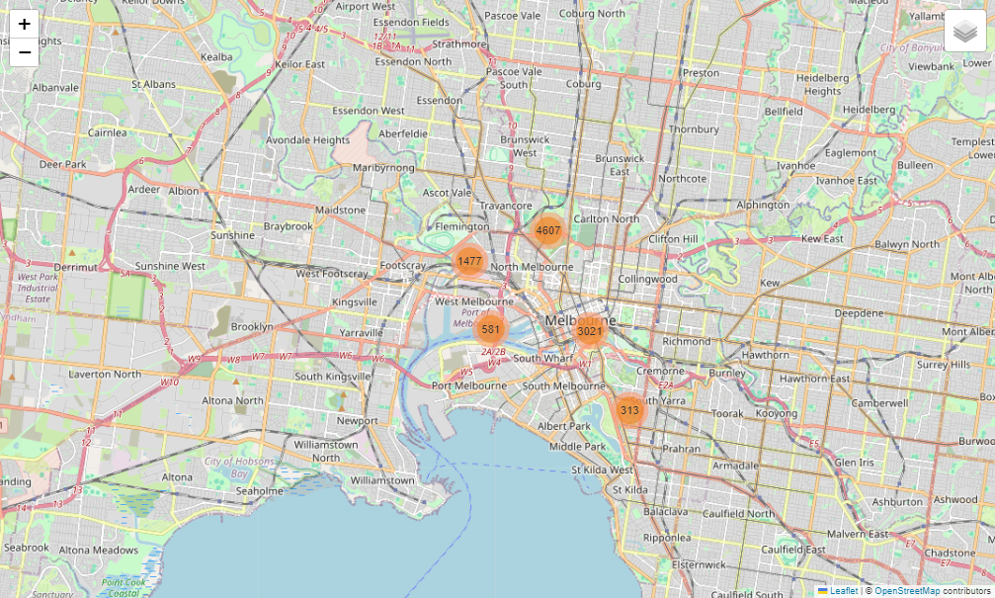

**10. Conclusion**

This tutorial offers a foundational approach to using Folium within a Jupyter Notebook to create dynamic and interactive maps. It is designed to help beginners understand and apply basic geospatial visualization techniques effectively. As users become more comfortable, they are encouraged to explore additional Folium features and customization options to further enhance their visualizations.

**Author**

Venuka 2024.v1